Flood Watch: A Targeted Approach to Inclusive Flood Preparedness for International Students

Daria, Lauri
Technische Hochschule Ingolstadt, lal2933@thi.de
Julia, Podlipensky
Technische Hochschule Ingolstadt, jup1439@thi.de
Yashika, Saxena
Technische Hochschule Ingolstadt, yas7171@thi.de
More intense extreme weather events make floods more common for the future. It is important to improve flood resilience for communities to empower people to plan for such events and mitigate its consequences. Flood preparedness of every individual therefore is crucial. But international students, especially due to language barriers and being new to the region, lack the familiarity with emergency systems and preparedness strategies in place. This report examines how UX design can play a transformative role in bridging this gap. By working on inclusive and user-centered resources, we aim to empower international students to take proactive steps for flood preparedness. Through background research, iterative design process and user testing with international students at Technische Hochschule Ingolstadt, this project represents a solution approach to address these challenges and contribute to the flood resilience of a diverse community.
CCS CONCEPTS • User Experience Design • Information Design •
Additional Keywords and Phrases: Flood Preparedness
- Introduction
The latest news about the floods in Valencia, Spain, remind us of the disastrous effect that extreme weather events can have on communities [8]. Floods are among the most destructive natural disasters, posing a growing threat to communities worldwide as climate change intensifies their frequency and severity [14]. The state of Bavaria is noted as one of the higher-risk areas in Europe for the future [17], as already in the recent floods of summer 2024 regions received a quantity of rainfall seen only once every 50 to 100 years, prompting dramatic flood evacuations and causing billions of Euros in damages [19] [20].
Flood resilience, which emphasizes reducing risks while enhancing self-organization to cope with climatic events, has become a central focus of research for flood risk management since 2017 [14]. Such disaster resilience is the ability of countries, communities, and households to maintain or transform living standards in the face of shocks or stresses [6]. Resilience complements traditional risk management by addressing challenges before, during, and after flood events [14]. This is particularly important in the before-flood phase, where preparedness, mitigation, and planning are essential for households and communities [14], therefore we focus on this stage for the project.
For international residents—who now account for 23.3% of the population in cities like Ingolstadt Bavaria [18] these challenges of facing a flood can be magnified, as they often encounter language barriers, limited awareness and access to localized resources. The need for effective flood preparedness is urgent. Acting now ensures we can mitigate risk, safeguard livelihoods, and foster resilience in communities that are increasingly vulnerable to climate-related disasters.
- Background
In Germany, water-related emergencies are managed at the state level, with municipalities handling pluvial flood risks, resulting in regional variations [13]. For effective flood preparation and response early warnings are essential, as the German Weather Service (DWD), the ongoing ISF Project and Warning-App “NINA” lead efforts to issue improved and early weather and flood warnings to the regions and its residents [13][7][4]. But warnings can only serve as a supportive source of information and should be supplemented with precautionary measures [16].
To be prepared for flood events, according to the Federal Water Act, every person who may be affected by floods is, as far as possible and reasonable, obliged to take appropriate precautionary measures [13] as in the event of a large-scale and serious disaster, the rescue workers cannot be everywhere [3]. The Federal Office of Civil Protection and Disaster Assistance (BBK) and the city of Ingolstadt provide emergency preparedness guide booklets on their website, with recommendations for floods, extensive preparedness tips & checklists and at municipal level the explanation of the city's emergency system and local contacts [3][10].
On our review of existing preparedness and risk information for international residents, we noticed that provided resources might be challenging to find or comprehend. Publicly available general flood risk information is not specifically tailored for different end-users [13]. While online resources, like BBK’s multilingual booklets and app [2] [3], provide extensive information, users must actively seek them out beforehand. Additionally, disparities in visual and content design, such as Ingolstadt city’s plain text translations for foreign residents versus visually formatted German guides [10], can hinder effective understanding, especially for newcomers.
- Research Findings
  - Initial Survey
To expand on our hypothesis, our initial 45 question survey assessed flood preparedness and accessible communication. Participants were 49 German native speakers and 31 non-native speakers from 15 different countries, with the survey reaching primarily university students residing in the Ingolstadt region. The key results are stated below.
87,7% of the non-native speakers face challenges in understanding flood preparedness resources. Language barriers were a recurring theme, with respondents also noting the lack of exposure to information they could comprehend. Adoption of official warning apps like “NINA” remains low across both groups, with only 12.9% of non-native and 29.3% of native speakers using them, which increases the risk of missing early alerts and updates for emergencies. Non-native participants also feel more disconnected from their communities, with the key finding that 74.4% don’t know whom to turn to for help during a flood. Reflecting this, 77.4% of non-native speakers expressed strong interest in joining a community group or platform for flood preparedness, compared to 41.5% of native speakers.
In conclusion, the surveyed international students face significant challenges, which could leave them vulnerable. But flood preparedness only works if it works for everyone. With 2 369 international students at the Technische Hochschule Ingolstadt (THI) making up 31,5% of the student body in the winter term of 2023/24 and the number more than doubling in the last two years [1], we made the decision to focus our project on this target group.
  - Expert Interviews
Parallelly, expert interviews were conducted to further our understanding of the topic with members of the following organizations: a volunteer student emergency worker from the Federal Agency for Technical Relief (THW), a volunteer humanitarian emergency worker & disaster protection consultant from Johanniter, and a member from the Federal Office of Civil Protection and Disaster Assistance (BBK). The key findings for our further project work are summarized below.
Need for encouraging proactive Preparedness: While early forecasting and regional disaster response, including communication with foreign residents during floods, is effective, communities can still face dangerous situations with flooded access routes impeding immediate help efforts. It was emphasized to involve citizens in preparedness efforts without inducing panic.
Enhancing Inclusive Communication: Accessible resources, including multilingual disaster alerts and preparedness guides across different mediums, are essential to ensuring that all residents can access critical information. Continuous improvements and targeted campaigns for the diverse population aim to close gaps - regardless of background, age and disability. Community ties also play a crucial role, as urban areas often lack close-knit networks, making it essential to foster and utilize digital community networks.
Recommendations for International Students: Experts agreed that international students can face unique challenges and the importance of providing guidance to help them navigate emergencies. It was suggested that universities could help by incorporating flood preparedness resources into orientation materials. Or promoting community events like drills or interactive fairs. Especially younger people lack awareness and experience of disasters, so the focus should be on providing simple, relatable examples, such as simulating rising floodwaters along familiar surroundings & objects or how to pack a “flood basics bag”. It is essential to create an emotional connection to improve comprehension and focus on simple, impactful steps.
  - Target group interviews
Through qualitative interviews with five international students at THI (from India, Turkey, Egypt, Mexico), we underlined the insights from our initial survey and gained a deeper understanding of their challenges and needs.
General Observations: The interviewed students largely lack direct personal experience with floods but some highlighted for example strong neighborhood support for minor emergencies in India, participating in emergency drills for earthquakes in Turkey or experiences of relatives with pluvial flooding in Mexico. Despite this they showed minimal awareness and preparedness for events like floods in Bavaria and how to handle them.
Pain points: Anxiety of even the thought of facing floods is common, expressing uncertainty about how to act during a flood or where to find safe spots and emergency plans. Many students lack the access to clear, simple resources or official emergency warnings, relying instead on friends, neighbors, or online translations to understand local situations. Warning apps were not provided by the student office nor the citizens' office during the residency registration process. Language barriers were a recurring issue, with the German emergency systems and content deemed as difficult to understand, which weakens engagement. Isolation and weak community ties further exacerbate their unpreparedness, as they don’t know how to connect with local resources or authorities. One student mentioned contacting embassies, as they perceive them to be more attuned to their situation as an international student in Germany. Concerns about communication failures during emergencies, such as losing internet access, added to their feelings of vulnerability.
Needs and Preferences for Tailored Flood Preparedness: The interviewed students emphasized their need for accessible tools for engaging in emergency strategies and flood preparation actions. Many expressed a desire for tailored multilingual flood preparedness resources, ideally in English, in visually digestible formats like step-by step guidance, infographics or videos. Frequently suggested were real-time alerts with actionable information, including affected areas, severity of risks, evacuation routes, and recommended steps, even when offline. Students also suggested interactive and practical preparedness methods, such as group-oriented drills, hands-on activities, or disaster fairs, which they found more effective than traditional workshops or written materials. They expressed a strong interest in fostering community connections, enabling communication and planning with peers or trusted individuals for support during emergencies. Overall, it's not only about translating information - international students need tailored support to understand the risks and act decisively during emergencies.
- Design Process
  - Ideation
Initially, our idea was fostering long-term preparedness for floods through interactive events, such as fairs, aimed at educating and motivating people to become more self-sufficient in disasters. Researching best practices from flood preparedness fairs around the world, we came across the “Io Non Rischio”-initiative at Lucca Comics & Games 2024 in Italy [11]. This campaign used innovative methods to promote disaster risk awareness among younger audiences, focusing on immersive experiences. Inspired by them, we planned university events to raise awareness, encourage preparedness, and build community among international students, including: Hands-On Workshops that e.g. teach emergency kit creation; Cultural adaptive sessions for flood preparedness advice; And Interactive AR Simulations to engage with flood scenarios and safety protocols.
However, despite the promise of such events, further evaluation revealed several significant limitations: Organizing and sustaining large-scale, multicultural events for international students would require significant financial and logistical resources. Additionally, while engaging activities may raise awareness, they often fail to produce long-term behavior changes, as one-time interventions may not lead to lasting preparedness [5]. Participants are likely to forget much of what they learned without continuous reinforcement, according to Ebbinghaus Forgetting Curve [12]. But ongoing follow-up campaigns or additional events are both costly and difficult to manage. These challenges prompted us to reconsider our approach and focus on a solution that prioritized practicality and immediacy.
By reevaluating our research and user-centered discussions, we decided to concentrate on the time period around 48-24 hours before a flood, when early alerts and warnings are issued [7][20]. This timeframe is particularly effective for flood preparedness, as international students, often unfamiliar with local disaster systems, are more likely to respond to applicable and actionable warnings. Effective communication is most impactful when it conveys a sense of urgency and a clear call to action [9]. Providing real-time, easy-to-follow guidance ensures that international students can act effectively, even if they haven’t prepared in advance. Focusing on preparedness for this time period also reduces the need for costly, long-term preparedness event efforts, maximizing impact while minimizing resource requirements.
This shift in the approach ensures that our solution meets international students where they are, both cognitively and emotionally, during the crucial pre-disaster period. In this critical timeframe, we bridge the gap between awareness and action, increasing the likelihood that international students will take the situation seriously and take necessary steps to protect themselves during floods.
  - Overview
After agreeing on the time frame for action, we focused on how to effectively connect with international students. We wanted to ensure they could access the necessary information and take action promptly. Given that state flood information wasn’t provided or tailored to them, we identified the need for a custom toolkit that would address their specific challenges. This led us to design an app that would serve as an alternative central hub for interactive flood preparedness resources adjusted for their needs: “Flood Watch”.

Key Objectives of Flood Watch:
- Equip students with the ability to assess their level of flood risk based on their specific location and situation.
- Provide clear, actionable steps for preparedness, presented in a simple, step-by-step format that students could easily follow even in a stressful situation.
- Ensure students could stay informed and take necessary actions, even without consistent internet access during the event.
- Address specific challenges such as language barriers, unfamiliarity with local resources, and lack of community connections, offering tailored support and solutions to help them navigate the situation effectively.

Challenge: One of the main challenges we faced was prompting international students to download the flood preparedness app before a flood. Students wouldn't typically feel the need to download an app solely for preparedness, and it would face the same adoption issues as existing warning apps and online resources. This led us to the critical realization that we needed an awareness mechanism that would reach students on already adopted and trusted mediums in a timely and effective way, driving them to download the app when it matters most - when the early alerts are issued.
Objective of the awareness mechanism: The goal of our awareness mechanism was to ensure the early flood warning reached students effectively, promoting immediate recognition of the flood’s severity and motivating them to take preparatory actions without delay. Building on the Extended Parallel Process Model, we utilize a balance of threat appraisal and efficacy appraisal in the messaging during this critical time [15].
We focused on reaching students through familiar and trusted communication channels. By delivering early flood alerts via university emails and the popular Neuland App’s push notifications (THI students app). By utilizing these established platforms, we ensure the message stands out and directs students to our app for personalized flood preparedness steps.
  - Key Features
Awareness mechanism: The journey begins when the user receives a notification about a potential flood. This notification leads to a message from the trusted International Students Office as displayed in Figure 1, which is designed to stand out through distinct visuals and urgency cues. It prioritizes clarity and accessibility, encouraging the user to take immediate action.
It highlights the severity of the situation, explains potential impacts like transportation disruptions and safety risks, and provides actionable steps like how to stay informed, preparing emergency kits, and planning evacuation routes.
A prominent call-to-action directs users to download the preparedness app offering tailored guides, real-time updates and connection with fellow students. The message reassures community support and contains additional emergency helpline details, maintaining a tone of care and preparedness.
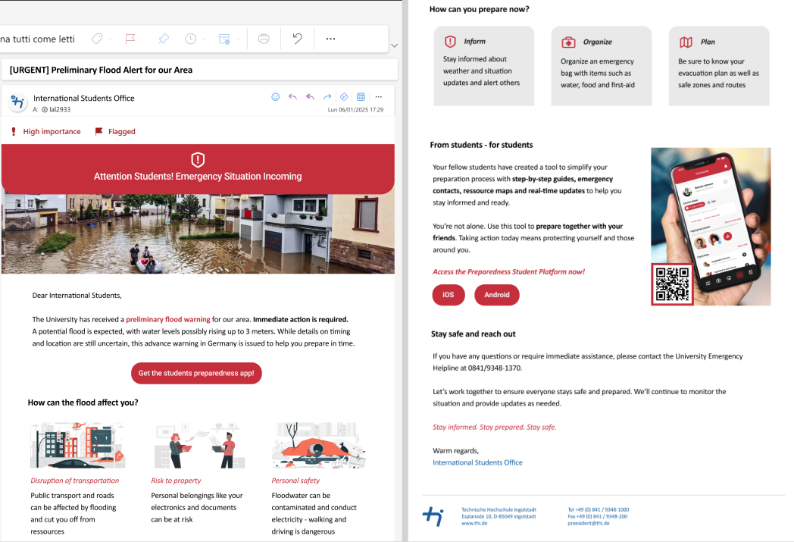
Figure 1: Split Screenshot of Awareness Mechanism Email as shown on THIs Outlook View
The App “Flood Watch”: Flood Watch is designed to prioritize user safety during potential flood events. After an initial assessment of the student's situation and needs, it automatically redirects them to the Emergency Mode. This mode provides an intuitive and streamlined interface tailored to delivering critical, time-sensitive information as showcased in the key screens in Figure 2.
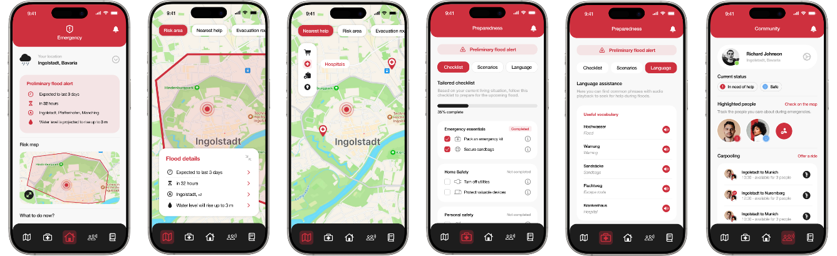
Figure 2: “Flood Watch” App – Screens from left to right: 1) Home, 2) Risk Map, 3) Nearest Help, 4) Tailored Checklist, 5) Language Assistance, 6) Community
Home: The home serves as the central hub in Emergency Mode, offering an overview of all details regarding the flood alert and of the app.
Risk map: The risk map is a dynamic map that shows the affected areas and includes: 1) Nearest Help Locations as nearby resources like food, hospitals, sandbag stations, and emergency points. 2) Evacuation Routes and including carpooling options to help others. 3) Highlighted People to track the status of important individuals like friends and check if they need assistance, promoting community support.
Preparedness: This section provides tools and knowledge to help users stay safe during a flood. It ensures users are ready and know what to do in various emergency scenarios. Divided in different sections: 1) Tailored Checklist that is personalized for outlining essential preparations for the student’s needs, like packing emergency kits, identifying safe zones, and securing documents. 2) Scenario based instructions that offer step-by-step guidance for different situations: At home: How to secure your home and prepare for evacuation; In the car: Safety tips for driving or finding shelter during a flood; Life-saving actions: How to help others safely. 3) Language assistance helps international students by providing flood-related vocabulary and useful phrases translated into the user’s native language and German. This ensures they can communicate and respond effectively during flood emergencies.
Community: The Community Section connects users, helping them stay informed and support each other during floods. It’s divided in: 1) Profile Management where users can update their status (e.g. safe / in need of help). 2) Highlighted People to track and manage key individuals, by checking their status, location and assistance needs. 3) Carpooling Options to coordinate evacuation with community members, enhancing mobility and reducing isolation. 4) Emergency Contacts with explanation and direct access to local emergency organizations, to familiarize with the emergency systems in place.
- Testing
  - Overview
The testing session involved users from diverse cultural backgrounds (India, Indonesia, Spain, UAE) to evaluate the effectiveness of the design for the emails and app features. For the testing process, we approached students from THI in their natural environment of studying in the library. This choice was intentional, as it closely mimics the real-life scenario where users would encounter a flood alert unexpectedly. Each participant was first shown email variants while thinking aloud and asked a series of targeted questions, followed by thinking aloud testing of the app prototype and concluded with additional questions.
Three email variants were tested for clarity, urgency, and effectiveness in prompting action. The app was assessed for navigation, emergency preparedness tools, international student support, and community fostering. Overall Feedback was collected on usability, communication preferences, and overall user experience to identify further improvements for the needs of diverse users.
  - Results
By incorporating diverse perspectives, we aimed to identify areas where our designs succeeded and areas where they needed refinement. Below are the key results for emails and the app:
Emails: The variant displayed in Figure 1, was the most effective in prompting action. Feedback for improvement mentioned to enhance the specific flood scenario better and highlight cultural considerations for international students more visually. Further suggested improvements include more distinctive CTA-Banners for immediate action and larger font. The shortest newsletter- like variant attracted attention with its layout but lacked action-oriented and relatable content and clear CTAs. A variant consistent with the design of THIs emails lacked the urgency of the situation.
App: Users appreciated the clear navigation, flood maps, and emergency preparedness features. However, navigation needs streamlining with a smart search for faster access to critical information. Features like "nearest help" and "highlighted people" were valued, with proposed enhancements such as information for more evacuation transport options and wider resource-sharing capabilities in the app. The interactive checklist was an important feature, but a global progress bar could potentially induce panic if not all preparedness measures can be taken. Milestone indicators with reassurance of essential preparedness were preferred. Further suggestions included simplifying the Ingolstadt Emergency Concept term “Lighthouses” to “Information & Assistance Points” and for some testers including access to self-organizing groups from their culture.
- Conclusion and Further Work
In the next design iteration, we can address the areas of visual communication, refine on the cultural considerations of our vast target group and integrate more tools to strengthen connections among users. Our long-term goal is to expand on the reach for other university communities with adjusted awareness mechanisms and include support for different types of disasters. With future wider testing of the refined design and evaluation of our interviewed experts, the design can evolve into a more intuitive and impactful solution for inclusive flood preparedness.
ACKNOWLEDGMENTS
We used Chat GPT for paraphrasing and shortening parts of the report, based on original content summarized and written by us. The Report states our original ideas, thoughts and processes.
REFERENCES
- Bayerisches Landesamt für Statistik. 2024. Studierende an den Hochschulen in Bayern - Wintersemester 2023/2024. Fürth. Retrieved January 19, 2025 from https://www.statistik.bayern.de/mam/produkte/veroffentlichungen/statistische_berichte/b3110c_202322.pdf
- BBK. 2021. Emergency information sources for international visitors in Germany. BBK. Retrieved January 19, 2025 from https://www.bbk.bund.de/EN/International-Visitors/international-visitors_node.html
- BBK. 2022. Personal preparedness. Retrieved January 20, 2025 from https://www.bbk.bund.de/EN/Prepare-for-disasters/Personal-Preparedness/personal-preparedness_node.html
- BBK. [n.d.]. The Federal Government/Länder ISF project “Warning of the Population.” Warnung der Bevölkerung. Retrieved January 19, 2025 from https://warnung-der-bevoelkerung.de/en/the-federal-government-laender-isf-project-warning-of-the-population/
- Tudor A. Codeanu, Antonio Celenza, and Ian Jacobs. 2014. Does disaster education of teenagers translate into better survival knowledge, knowledge of skills, and adaptive behavioral change? A systematic literature review. Prehospital and Disaster Medicine 29, 6: 629–642. https://doi.org/10.1017/S1049023X14001083
- Department for International Development. 2011. Defining Disaster Resilience: A DFID Approach Paper. Retrieved from https://assets.publishing.service.gov.uk/government/uploads/system/uploads/attachment_data/file/186874/defining-disaster-resilience-approach-paper.pdf
- DWD. [n.d.]. Wetter und Klima - Deutscher Wetterdienst - Warnungen aktuell - Warnstufen und Farbskala. Retrieved January 19, 2025 from https://www.dwd.de/DE/wetter/warnungen_aktuell/kriterien/warnstufen.html
- ESA. 2024. Devastating floods in Spain witnessed by satellites. Retrieved January 19, 2025 from https://www.esa.int/Applications/Observing_the_Earth/Devastating_floods_in_Spain_witnessed_by_satellites
- FEMA. 2014. Lesson 3. Communicating in an Emergency. Retrieved from https://training.fema.gov/emiweb/is/is242b/student%20manual/sm_03.pdf
- Stadt Ingolstadt. Ratgeber für Notfallvorsorge - richtiges Verhalten in Krisensituationen. Stadt Ingolstadt. Retrieved January 19, 2025 from https://www.ingolstadt.de/Rathaus/Recht-Ordnung/Feuerwehr/Ratgeber-f%C3%BCr-Notfallvorsorge/
- Io Non Rischio. 2024. L’attimo decisivo al “Lucca Comics and Games 2024. Retrieved January 19, 2025 from https://www.iononrischio.gov.it/it/notizia/lattimo-decisivo-al-lucca-comics-and-games-2024/
- megha. 2023. Ebbinghaus’ Forgetting Curve. RapL. Retrieved January 19, 2025 from https://getrapl.com/blog/ebbinghaus-forgetting-curve/
- Swenja Surminksi, Viktor Roezer, and Maryam Golnaraghi. 2020. Flood Risk Management in Germany: Building flood resilience in a changing climate. Flood Risk Management. Retrieved from https://www.genevaassociation.org/sites/default/files/flood-risk-management-germany.pdf
- Lihong Wang, Shenghui Cui, Yuanzheng Li, Hongjie Huang, Bikram Manandhar, Vilas Nitivattananon, Xuejuan Fang, and Wei Huang. 2022. A review of the flood management: from flood control to flood resilience. Heliyon 8, 11: e11763. https://doi.org/10.1016/j.heliyon.2022.e11763
- Kim Witte. 1992. Putting the fear back into fear appeals: The extended parallel process model. Communication Monographs 59, 4: 329–349. https://doi.org/10.1080/03637759209376276
- Umweltbundesamt. 2022. Flood warning. Retrieved January 20, 2025 from https://www.umweltbundesamt.de/en/topics/water/extreme-events-climate-change/floods/flood-warning
- XDI. 2024. 2024 XDI Gross Domestic Climate Risk Report. Retrieved January 19, 2025 from https://77af07411.flowpaper.com/2024XDIGlobalDomesticClimateRiskReport/
- Destatis. 2023. Karte: Statistiken zu Ausländern und Schutzsuchenden (Flüchtlingen). Retrieved January 20, 2025 from https://service.destatis.de/DE/karten/migration_integration_regionen.html#ANT_AI
- DW. 2024. German insured flood damage estimated at €2 billion. dw.com. Retrieved January 20, 2025 from https://www.dw.com/en/german-insured-flood-damage-estimated-at-2-billion/a-69306995
- DW. 2024 Southern Germany hit by catastrophic flooding. dw.com. Retrieved January 20, 2025 from https://www.dw.com/en/southern-germany-hit-by-catastrophic-flooding/a-69239541

